Experiment-8

Create a Virtual Hard Disk and allocate the storage using VM ware Workstation

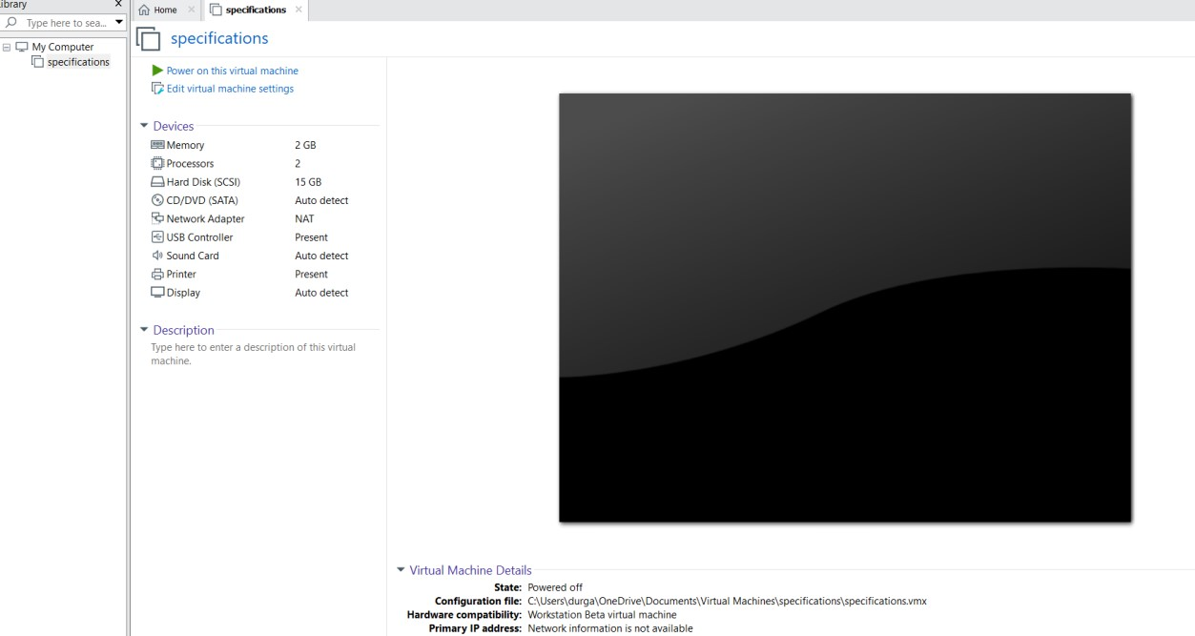

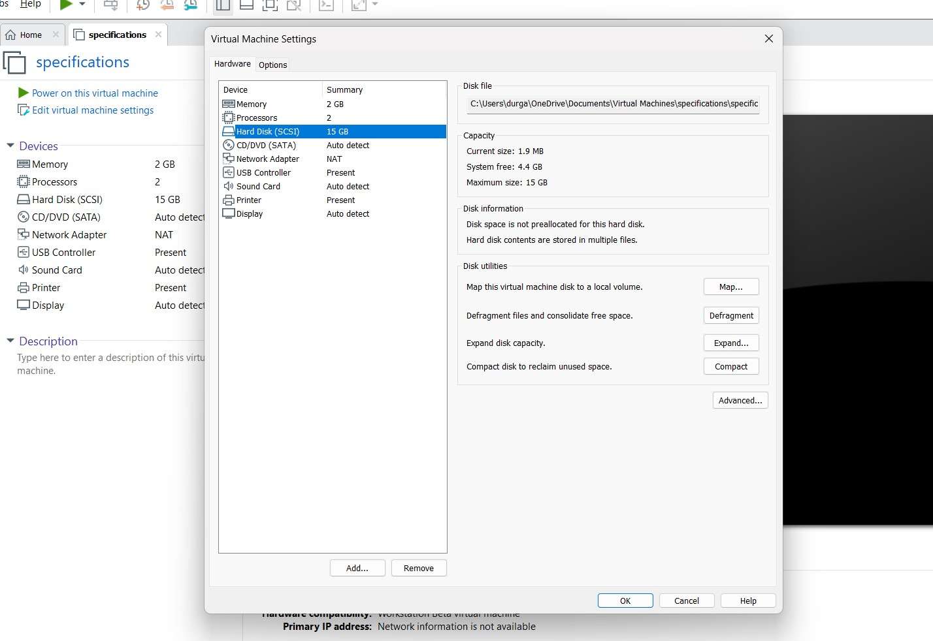

Shaik muzamil 192224118

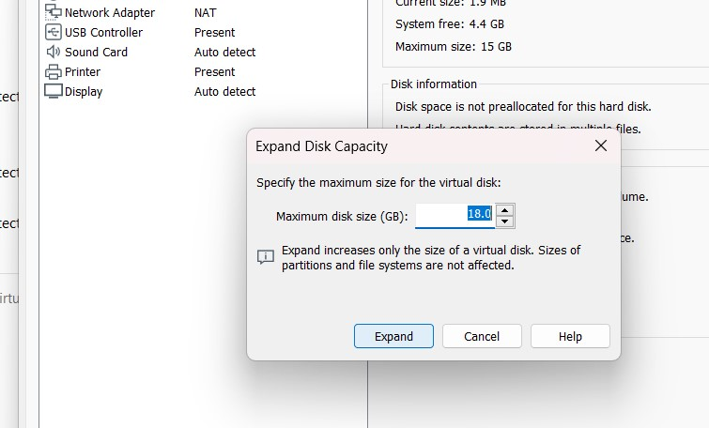

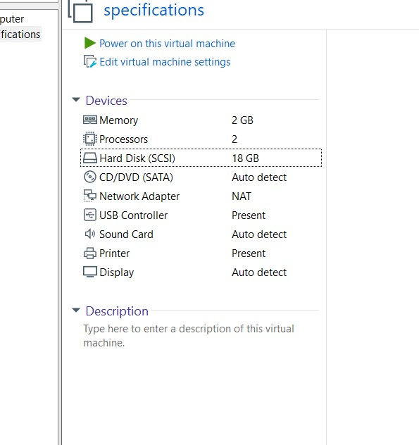

Shaik muzamil 192224118